**Data Wrangling and Merging Tasks**

1. Import Movies_Info.csv file into SAS Enterprise Guide. In step “3 of 4”, change the name of the column “movie_title” to “movie_name” to match with the IMDB_Reviews.csv file. Also, in this step, review the column data types and make sure that the imported types are as they should be.

**Response:**

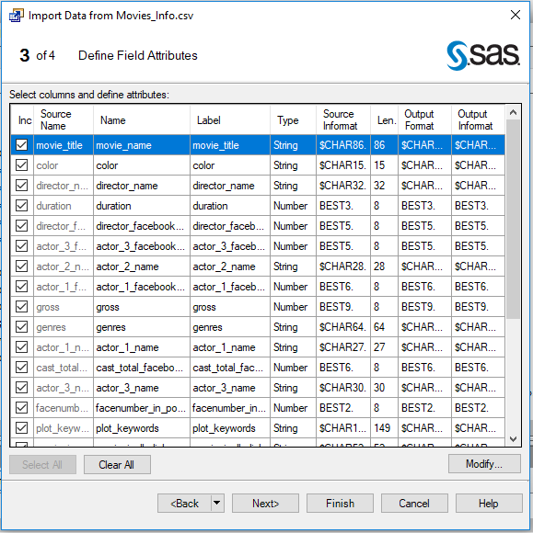

1. View the data characteristics of the various columns and list any data issues you identify. [Hint: From the Tasks, select Describe and then Characterize Data.] In particular, identify if the data has any of the following issues and support it with appropriate screenshots in a Word document:
2. Missing values

* actor_2_name has 13 missing values

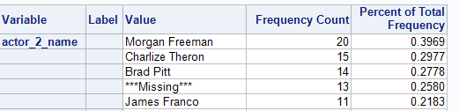

* actor_3_name has 23 missing values

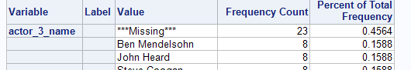

* color has 19 missing values

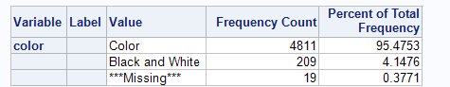

* content_rating has 303 missing values

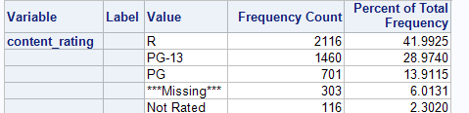

* country has 5 missing values

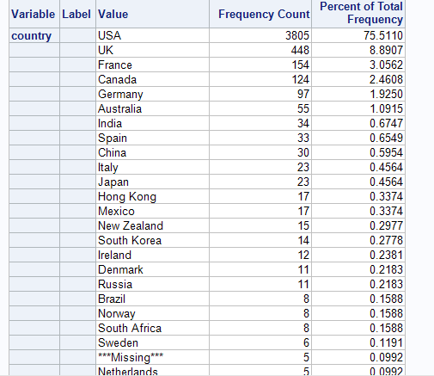

* director has 103 missing values

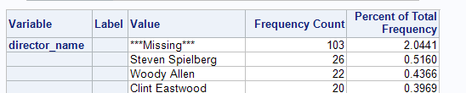

* language has 12 missing values

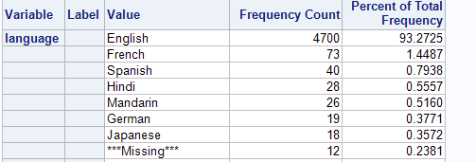

* plot_keyword has 153 missing values

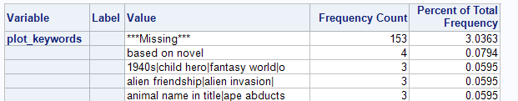

* actor_1_facebook_likes has 7 missing values



* actor_2_facebook_likes has 13 missing values



* actor_3_facebook likes has 23 missing values



* aspect_ratio 328 missing values



* budget has 491 missing values



* director_facebook_likes has 103 missing values



* duration has 15 missing values



* facenumber_in_poster has 13 missing values



* gross has 882 missing values



* title_year has 107 missing values



1. Mislabeled values
   * There are no mislabeled values
2. Duplicate records
   * movie_name has duplicate values

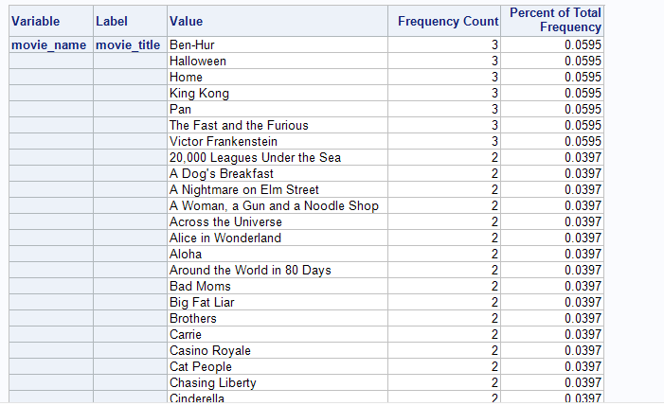

* + movie_imdb_link has duplicate values

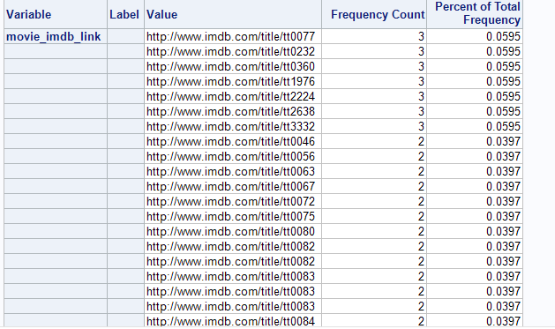

1. Invalid range in any of the numeric or date columns

* budget has invalid range of values with min budget as 218 and max budget as 12215500000 which seems to be incorrect.

1. Suggest a plan of action for each of the above identified issue.
   1. actor_2_name, actor_3_name : Missing values are a valid case, as there are movies with just 1 or 2 actors, so this is ok.
   2. color: The number of missing color values are less than 5% of the total, so we will remove the records with missing color values (19 records).
   3. content_rating: All the 303 missing values can be updated to ‘Not –Rated’ so as to not lose the valuable data.
   4. country: There are just 5 missing values, so we will remove the records with missing country.
   5. director_name: The number of missing director_name values are less than 5% of the total, so we will remove the records with missing director_name values (103 records).
   6. language: There are just 12 missing values, so we will remove the records with missing language.
   7. plot_keywords : The number of missing plot_keywords values are less than 5% of the total, so we will remove the records with missing plot_keywords values (153 records).
   8. actor_1_facebook_likes, actor_2_facebook_likes, actor_3_facebook_likes, director_facebook_likes: The missing values present a valid case, as these actors and directors may not have a facebook page hence no likes.
   9. aspect_ratio: The number of missing aspect_ratio values are close to 6% of the total, but we cannot add any default value here as the aspect ratio varies from year to year the movie was made, so we will be dropping this field.
   10. facenumber_in_poster: Missing values are a valid case, as the movie poster may not have any faces of actors, so this is ok.
   11. duration: There are just 15 missing values, so we will remove the records with missing duration.
   12. gross: We will replace the missing 882 values in gross column with the mean of gross.
   13. title_year: The number of missing title_year values are less than 5% of the total, so we will remove the records with missing title_year values (107 records).
   14. budget: We will remove the records with unacceptable budgets with an assumption that the acceptable range is 1400 to 300000000. So, delete records with budget < 1400 or budget >300000000, while keeping records with missing values and then replace missing budget with mean of budget (from the non-missing records).
   15. movie_name and movie_imdb_link: This surely looks like there are duplicate records and resolving duplicates from movie_name will resolve the duplicates in movie_imdb_link as well. We will sort the data and keep one of the duplicate record and deleting the other. If the duplicate records still exists after sorting, since we cannot determine which record has the true movie_name without additional information we will remove both records with duplicate movie_name. We will remove all the duplicate movie_name records.